GPT Band: 7
The diagram below shows the floor plan of a public library 20 years ago and how it looks now.
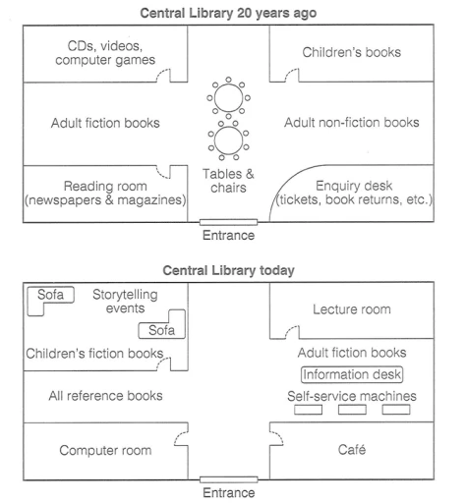
The provided diagram illustrates the sequential stages involve in the floor plan of a public library, also demonstrating the transformation how it was two decades ago, and how it looks now.
Overall, the process consists of reallocating of furniture and rearrange books according to their genre.
A detailed observation indicate that the process commences with entrance. Firstly, old library had a sitting area to welcome readers in the library where Tables & chairs are placed. In contrast, now sitting settings shifted in inner library. Subsequently, there were a section for children’s books conversely, that segment of library is now dedicated for Lecture room whereas, Children’s books are shifted in the north west corner of the library and now they can enjoy storytelling events, fiction books, as well as sitting arrangements.
In addition to this, in the left side of the library use to be segmented for adult non-fiction books, but now this portion have more amenities such as fiction books for adults, importantly an information desk, and Self-service machines to search for books. Over and beyond that, there is a cozy cafeteria in the left bottom side of the library. In parallel but opposite side, there is a computer room where individuals may read e-books, search online, work on personal research projects. Over and above that, there are all reference books which are mostly consulted by the PHD students or researchers. Finally, sequential and step by step development made the library more organize well equipped with technology.

